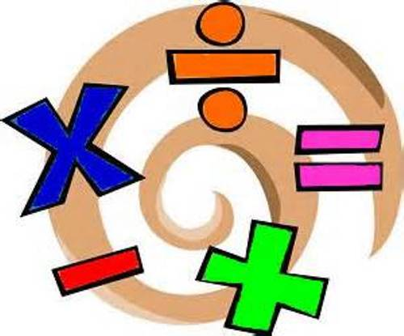
Ideas for Mastery Maths at home.

Addition:
Snakes and ladders
Dominoes
“Bus Stop” game by Orchard Toys.
Addition using objects from around the house.
Bowling: what is your total score?
Coins/ prices in supermarkets.

Subtraction:
Subtraction using objects from around the house.
Bowling: how many pins are you left with?
Place Value:
Child friendly “Countdown” e.g. 5, 10, 3 and 7 how would you make 24?
Playing cards.
Dominoes.
Next step from number plates and house numbers: How many tens and ones are there? How many more to get to the next set of 10?
Which pairs of numbers make that number?
Make your own 100 square and spot patterns.
Multiplication:
Count in steps of 2,3,4,5,10’s up and down the stairs.
Making groups of everyday objects e.g. 5 apples, 5 spoons and 5 socks = 15/ 5’s pattern.

Division:
Sharing household objects out equally.
Sharing treats equally amongst your friends and family.

Shape:
2d and 3d shape hunt
Sort 2d and 3d shapes by properties.
Make 3d shapes
2d shape picture.
Pattern using shape.
Playing cards.
