 | Client Name: |  | Click or tap here to enter text. |  |  |  |  | Click or tap here to enter text.
 |  |  | First name |  |  |  |  | Last name
 | Address: |  | Click or tap here to enter text.
 | Postcode: |  | Click or tap here to enter text. |  |  |  |  | Phone no: | Click or tap here to enter text.
 | No. of household members: |  |  | Adults Click or tap here to enter text. |  |  |  | Children Click or tap here to enter text.
 | Agency Name |  |  | Click or tap here to enter text. |  |  |  | Agency Contact number: |  | Click or tap here to enter text.
 | Referrer Name: |  | Click or tap here to enter text. |  |  |  |  | Date: |  | Click or tap here to enter text.
Community Café Gift Card Please tick Gift Card required:

 | Brunswick Hub Chilled Goods | ☐ |  | SYDNI Food Co-op |  |  |  | Small household Veg bag |  |  | ☐
 | Half a dozen eggs | ☐ |  |  |  |  |  | Family Veg Bag |  |  | ☐
 | Dozen eggs | ☐ |  | SYDNI Café |  |  |  | SYDNI Café meal and drink |  |  | ☐
 | Please describe the nature of the crisis (Tick All that apply)
 | Benefit Changes |  | ☐ |  |  |  |  | Benefit delays |  |  | ☐
 | Low Income |  | ☐ |  |  |  |  | Debt |  |  | ☐
 | Homeless |  | ☐ |  |  |  |  | Delayed Wages |  |  | ☐
 | Sickness/Ill health |  | ☐ |  |  |  |  | No recourse to Public funds |  |  | ☐
 | Has the Coronavirus pandemic had a direct influence on the crisis? Yes |  |  |  |  |  |  |  |  |  | ☐
 | Would the client like any additional support or signposting? |  |  |  |  |  |  |  |  |  | Yes | ☐
 | If Yes, please provide preferred phone number
The Community Café Gift Card has no monetary value and should be redeemed within a week if possible. As community organisations we take data protection very seriously and your information will be stored on a secure database. We use this data anonymously for monitoring statistics relating to the project. Your information will only be shared by SYDNI with the organisation that needs to redeem your gift card in order for them to issue the gift and perform their own anonymous monitoring reports. To help us to prevent misuse of the gift card food scheme, centres may share dates that you have used the service with some referrers and our partners.
No information that would identify you as an individual will be shared or published without your specific consent unless we have a legal or safeguarding duty to do so.
Please email this referral for to manager@sydni.org or take a copy of this form to your nearest community hub as listed below.

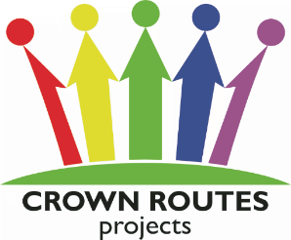
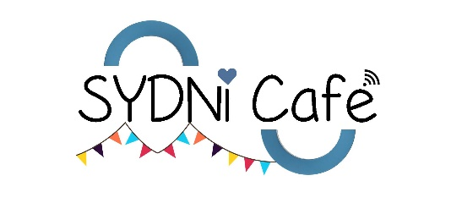

Enquiries: SYDNI 01926 422071
Brunswick Hub 01926 422123

Office Use: Contact date ………………………….. Gift card number ………………………..
Reg Form …………………………………………… Order taken ……………………….
Collection date …………………………..……………… Card reimbursed …………..............

