Here’s what I hope are a few helpful tips for tuning a violin or viola at home. I recommend that you try to tune before the lesson so that we can avoid wasting too much time doing this once the lesson starts. I will give a few steps here but have a look at a recommended website video below if you need to see how it’s done.
- You will need to tune to a standard A440 hertz. There a free tuning apps online which provide the notes of the violin. Start with A, pluck or bow it and see if it matches the pitch. Then progress to D, G and E last. Some apps just play each string’s pitch, others provide a green light or needle for precision. If you have an electronic keyboard at home, it would be perfectly fine to tune to. Acoustic pianos may have a different A from house to house if they haven’t been tuned lately.
On Google Play: Master Violin Tuner app, https://apps.apple.com/us/app/simply-tuner-violin-cello/id1300058854
On Android: Violin Tuner app
- For most tuning you may only need to turn the fine tuners which are located on each string on the black triangular tail piece located near the bridge. If the note sounds too low the tuner gets turned clockwise to make it higher, if it’s too high, counter clockwise to make it low.
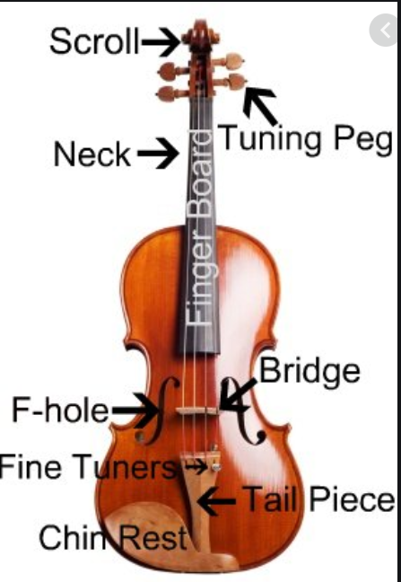

- If the string is loose or really out of tune, then you must use the tuning peg. Be sure that the peg you are going to turn is wound with the string out of tune. If you need to make the string sound higher, turn the peg slowly while pushing inwards; never turn quickly or suddenly. If the peg is quite stiff, try turning it gently backwards and forwards to loosen, but then turn forwards while pushing in gradually.
There are many videos on YouTube so do have a look, they obviously vary in quality! This one is recommended by the European String Teachers Association
https://www.violinist.com/blog/laurie/20203/28139/
I would suggest also downloading a free metronome app: android Pro Metronome app which is great for setting the beat or trying to play in time. Google Play will have some available too.

