Practice tips for the beginner violinist :
To be used by parents and carers to support their instrumentalists at home

Violin hold: Be sure to stand up tall. Try to use a shoulder rest or big sponge attached with an elastic band to keep the violin in place on your shoulder. This will prevent you from hunching your shoulder which leads to bad posture. The violin should come off the left shoulder and align with the left leg facing forward.
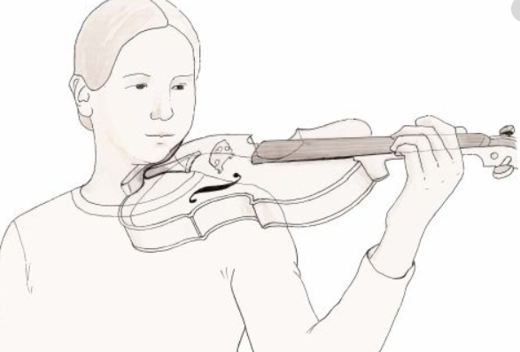
Placing the fingers on the string: the left hand moves away from the “belly” of the violin down to the end of the fingerboard. The thumb rests against the first sticker and is a guide to where the hand position should start. The thumb doesn’t actually do anything apart from keeping the hand in place. The wrist needs to be straight, and the fingertips come down to the stickers on the string. The first sticker at the end of the fingerboard is for finger one, second for 2, etc. When doing a song like Morning Sunshine which starts on second finger, place the first and second finger down together.
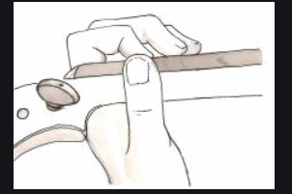
Bowing:
Always keep the little finger in place near the pin. Relax the other fingers slightly over the stick at the heel. The thumb should be under the heel and in a relaxed position. Do “window wipers” to warm up the bow hold. Play songs like Jig, Manhattan Blues, and At the Ballet to warm up your bowing.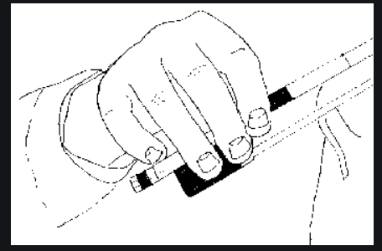
Bowing parallel to the bridge: for the best sound try to keep your bow straight, or parallel to the bridge. The bow should not wander over the fingerboard or go too close to the bridge. Use shorter bow strokes for faster tunes, longer bow strokes for slower tunes.
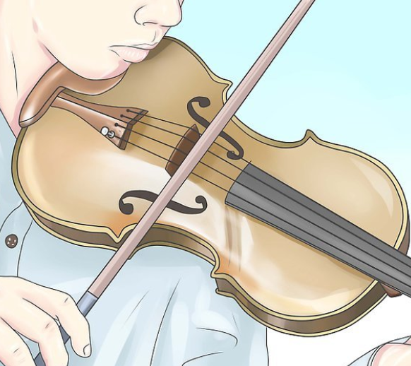

Practice makes enjoyment!
You might have expected me to say practice makes perfect, but we are looking for enjoyment in playing our violin and playing new songs and sharing music with others. Practise for your parents or grandparents. Show them something you can do. When you feel ready, play along with the CD. Try to play your violin at least 4 times a week for at least 15 minutes a time. Be sure to play the songs written in the diary and think about the tips above. The more you play a song the easier it gets and the better it sounds. Have fun!

