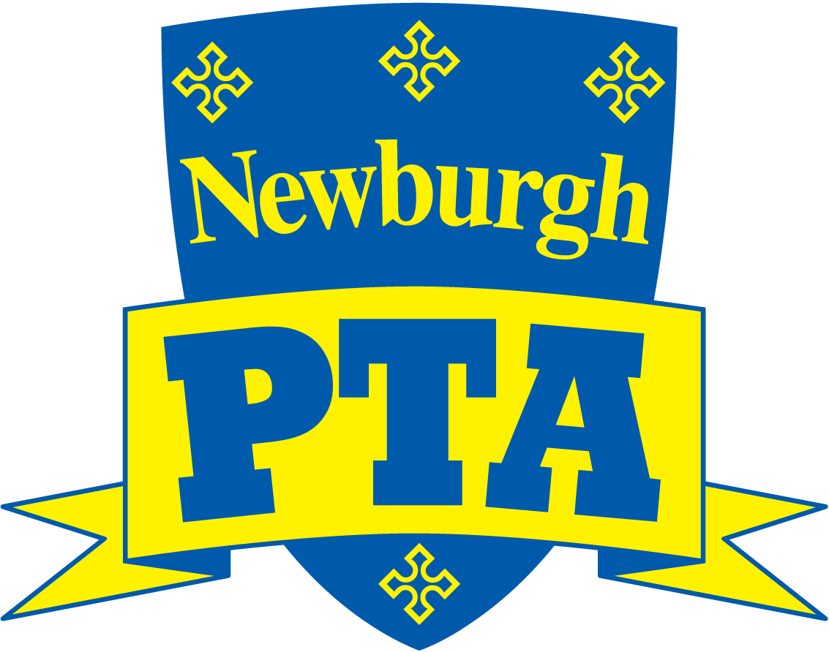
Newburgh Primary School PTA
Registered Charity No. 1144280
Email: newburghpta@gmail.com
C/o Newburgh Primary School, Kipling Avenue, Warwick, CV34 6LD

PTA Meeting at 6.30pm on Wednesday 2 November 2016 in the Staffroom.
Apologies should be sent to a committee member to be recorded with The Secretary. Please notify the Chair (in advance of the meeting) if you have any items under AOB. Minutes and other information can be found on our site on www.newburghpta.co.uk
Agenda
1. Welcome (and introduction if applicable) and list members present
2. Apologies
3. Approval of minutes of the last meeting
4. Update on Actions from the previous meeting
5. Treasurer’s Report
6. Request for funds from school / ideas & suggestions for how to spend funds.
6.1: Update on Outdoor staging
6.2: Scooter Shelter
7. Future events
7.1: Christmas Fair (Sat 3rd December) & Donation day (Fri 2nd December)
7.2: Filming of Christmas productions
7.3: Beetle Drive
8. Update on Events since last meeting:
8.1: Cake sale/ Second hand uniform sale
8.2: Reception tea Party
9. Website
10 Promoting Matched Giving
11. 100 Club Draw for October
12. Any other business
13. Next meeting date – Tuesday 29th November 7pm in The Unicorn Pub, Chase Meadow.

